In the name of beauty



The 7th problem set solution of Optical Networks course

* 1. No, because optical reach highly depends on the SNR of the lightpath (as optical reach is defined as maximum tolerable distance for the transmission SNR to remain above a threshold). The SNR itself is calculated through mathematical models that take link spectrums as input, consecutively bundling the optical reach to link spectrums.
  2. No. By allowing each node in the lightpath to potentially provide regeneration (e.g, in selective regeneration scheme), only re-amplification can boost the signal to continue in the lightpath.
  3. Yes, because minimum regeneration (e.g. re-amplification) can be performed, thereby reducing the total implementation cost.
  4. No. Regenerators are cheaper than transceivers (by a factor of about 80%) and favorable since they can regenerate signal all optically.

1. If the net gain of any span in the link is 0 dB, there is no amplification or attenuation imposed on signal power, hence maintaining a constant power throughput the lightpath. Assume a lightpath consists $N$ total spans, with the $k$-th span adding a noise with variance $σ_{k}^{2}$ to the signal. As there is no amplification or attenuation, the noise variances add up at the end of the lightpath as:

$$σ_{tot}^{2}=\sum_{k=1}^{N}{σ_{k}^{2}}$$

Assuming the lightpath launch power to be $P$, by dividing the sides of the latter equation by this value we obtain:

$$\frac{1}{OSNR_{tot}}=\sum_{k=1}^{N}{\frac{1}{OSNR_{k}}}$$

in which

$$OSNR_{k}=\frac{P}{σ_{k}^{2}}$$

is the OSNR at the end of the $k$-th span and $OSNR_{tot}$ is the total OSNR of the lightpath. It could be observed that the reciprocals of the spans’ OSNRs add up to obtain the OSNR of the lightpath, making them a good choice as span (or link) metric.

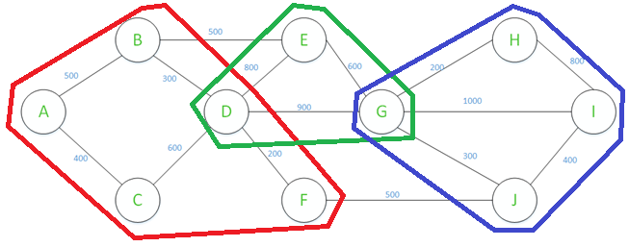

1. The noise figure of a cascade of 5 amplifiers can be given by

$$F_{tot}=F_{1}+\frac{F_{2}-1}{G_{1}}+\frac{F_{3}-1}{G_{1}G_{2}}+\frac{F_{4}-1}{G_{1}G_{2}G_{3}}+\frac{F_{5}-1}{G_{1}G_{2}G_{3}G_{4}}$$

where both the gains and noise factors are in linear scale. With all the links having a net gain of $0dB$ and a noise factor of $20dB≡100$, the total noise factor can be calculated as

$$F_{tot}=496≡26.95dB$$

1. The gain of the first link is improved by $4dB$ to get to $2dB≡1.58$ with the second link having a net gain of $-2dB≡0.63$ and all other links each having a net gain of 1. The noise factor is

$$F_{tot}=459.46≡26.62dB$$

with an improvement of $∼0.33dB$.

1. No. The noise figure will still be the same, as the other links have a net gain of $0dB≡1$.
2. In the new scenario,

$$F_{tot}=552.90≡27.43dB$$

which means that is it better from a NF perspective to under-amplify and then over-amplify a signal rather than first over-amplifying and then under-amplifying it.

1. The NF relation is

$$NF\left(dB\right)=0.75L+3.5$$

where $L(dB)$ is the span loss.

$$L=80×0.23=18.4dB→NF=17.3dB$$

The total noise figure is given by

$$NF_{tot}\left(linear\right)=F_{1}+F_{2}-1+F_{3}-1+F_{4}-1+⋯$$

or

$$NF_{tot}\left(linear\right)=1+N(F_{i}-1)$$

when all the noise figures are equal. Hence

$$N=\frac{{10}^{3.3}-1}{{10}^{1.73}-1}=38$$

which gives a total reach of $38×80=3040km$.

$$L=80×0.19=15.2dB→NF=14.9dB$$

therefore

$$N=\frac{{10}^{3.3}-1}{{10}^{1.49}-1}=67$$

which gives a total reach of $67×80=5360km$.

1. The relation of Raman amplifier NF with respect to its gain ($G_{Raman}$) can be given by:

$$NF_{Raman}\left(dB\right)=-0.25G\left(dB\right)+24.25$$

Since the EDFA noise figure is $6dB$, one can find the total noise figure (linear) as:

$$NF_{tot}\left(linear\right)={10}^{-0.025G+2.425}+\frac{{10}^{0.6}-1}{{10}^{\frac{G}{10}}}$$

which should be minimized subject to the full span loss compensation constraint which is:

$$G+G_{EDFA}=20$$

$$G≤18$$

$$G_{EDFA}≤7$$

Both the functions ${10}^{-0.025G+2.425}$ and $\frac{{10}^{0.6}-1}{{10}^{\frac{G}{10}}}$ are strictly decreasing with respect to $G$. Hence the minimum NF can be obtained with $G_{Raman}=18dB$ and $G_{EDFA}=2dB$ where its value is .

* 1. The one-step RWA imposes more complexity as it considers both routing and wavelength assignment together to find the optimum path. The multi-step RWA alleviates this challenge by considering routing and WA separately, at the cost of more sub optimum paths or extra costs imposed by extra regenerations but leading to faster RWA process which makes it favorable when the network is not heavily loaded.
  2. The idea behind the Most-Used WA scheme is that we use the least possible number of wavelengths in network by allocating, at each step of the algorithm, the currently most used wavelength. Ideally, it would have been best if all the lightpaths were assigned same wavelength in a perfect world!

1. We have the following path graph:

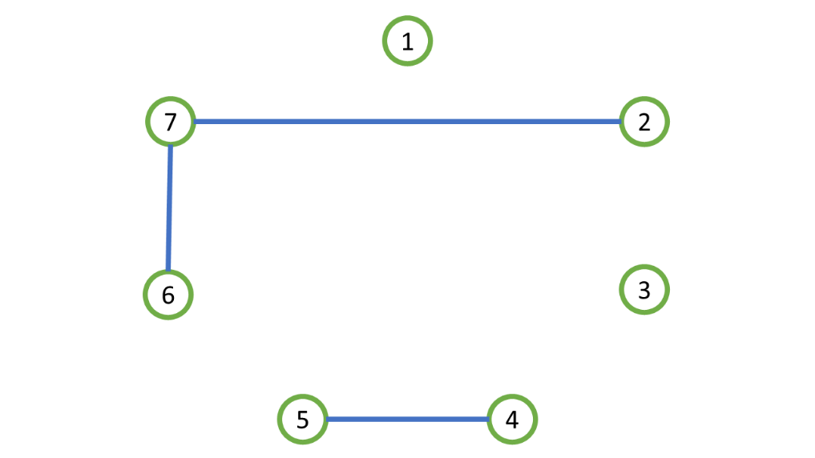

where we may assign the following set of wavelengths with both first-fit and most-used as:

|  |  |  |  |  |  |  |  |
| --- | --- | --- | --- | --- | --- | --- | --- |
| Lightpath ID | 1 | 2 | 3 | 4 | 5 | 6 | 7 |
| Wavelength | $$λ_{1}$$ | $$λ_{1}$$ | $$λ_{1}$$ | $$λ_{1}$$ | $$λ_{2}$$ | $$λ_{1}$$ | $$λ_{2}$$ |

1. The path graph can be sketched as follows:

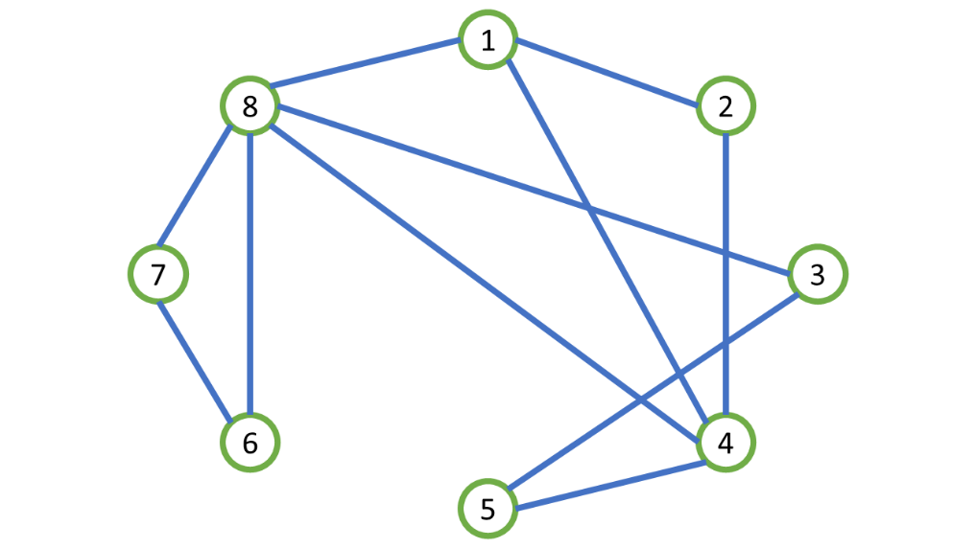

Once again, the result is the same for both first-fit and most-used:

|  |  |  |  |  |  |  |  |  |
| --- | --- | --- | --- | --- | --- | --- | --- | --- |
| Lightpath ID | 1 | 2 | 3 | 4 | 5 | 6 | 7 | 8 |
| Wavelength |  |  |  |  |  |  |  | ? |

* 1. We label the lightpaths as:

|  |  |  |  |  |  |  |
| --- | --- | --- | --- | --- | --- | --- |
| Lightpath | 2-1-5 | 1-5-4-6 | 5-4-3 | 6-4-3-2 | 6-3-2-1 | 5-6-3 |
| Label | 1 | 2 | 3 | 4 | 5 | 6 |

hence, the path graph can be sketched as:

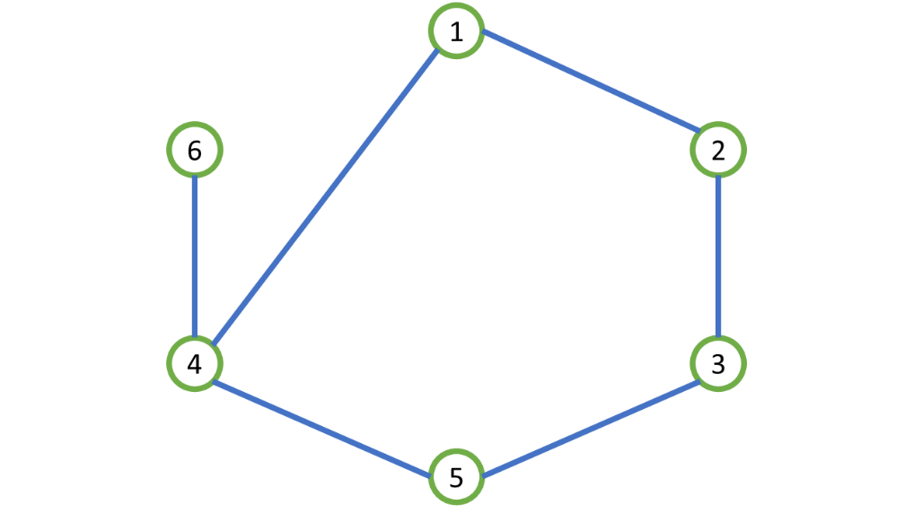

with the following WA output of the LDF heuristic method:

|  |  |  |  |  |  |  |
| --- | --- | --- | --- | --- | --- | --- |
| Lightpath | 2-1-5 | 1-5-4-6 | 5-4-3 | 6-3-2-1 | 6-4-3-2 | 5-6-3 |
| Label | 1 | 2 | 3 | 4 | 5 | 6 |
| Wavelength | 2 | 3 | 1 | 1 | 2 | 2 |

* 1. 3
  2. In this case, the lightpaths 1-5-4-6, 6-4-3-2 and 5-4-3 can be broken to two lightpaths of different wavelengths. Generally, degree zero or one nodes in path graph (corresponding to lightpaths that have common links with at most one other lightpath) are no bottleneck in WA process; they can be wavelength allocated the last. Based on this reasoning, the lightpath 5-4-3 appears in the path graph as two degree one nodes. Lightpaths 1-5-4-6 and 6-4-3-2 break down to pairs [1-5-4 , 4-6] and [6-4 , 4-3-2], respectively. Since lightpaths 6-4 and 4-6 are zero degree in the path graph, they can be assigned independently from the rest of the network. All in all, the lightpaths now effectively appearing in the new path graph are:

|  |  |  |  |  |  |
| --- | --- | --- | --- | --- | --- |
| Lightpath | 2-1-5 | 1-5-4 | 6-3-2-1 | 4-3-2 | 5-6-3 |
| Label | 1 | 2 | 3 | 4 | 5 |

with the following path graph and WA output:

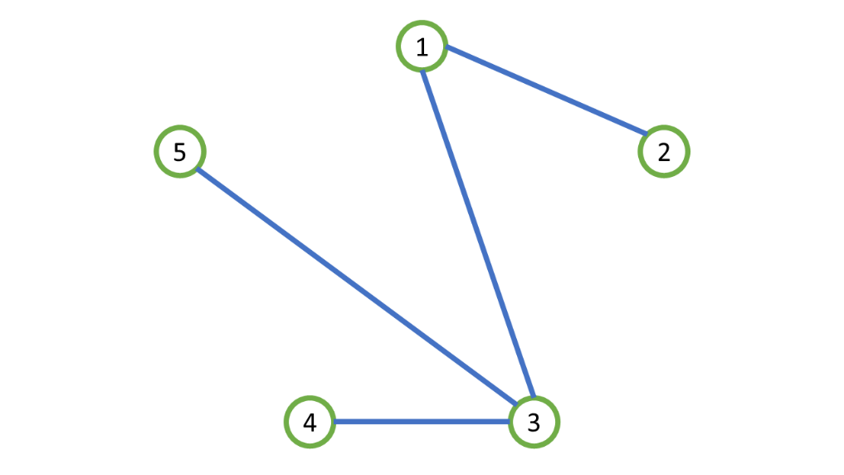

|  |  |  |  |  |  |
| --- | --- | --- | --- | --- | --- |
| Lightpath | 2-1-5 | 1-5-4 | 6-3-2-1 | 4-3-2 | 5-6-3 |
| Label | 1 | 2 | 3 | 4 | 5 |
| Wavelength | 2 | 1 | 1 | 2 | 2 |

As seen, we have saved a full wavelength in WA process using regeneration.

1. The path graph is:

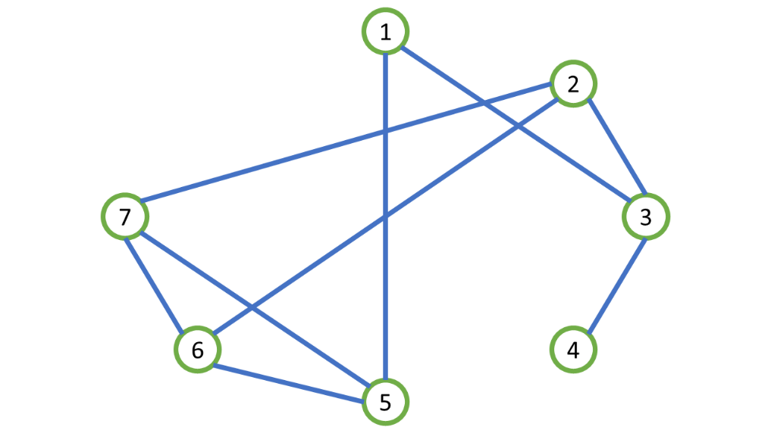

with the wavelength assignment order 5-6-7-3-2-1-4.

|  |  |  |  |  |  |  |  |
| --- | --- | --- | --- | --- | --- | --- | --- |
| Lightpath | 1 | 2 | 3 | 4 | 5 | 6 | 7 |
| Wavelength | 2 | ? | 1 | 2 | 1 | 2 | 3 |

1. Assuming the lightpaths are labeled in the following order:

|  |  |
| --- | --- |
| 1. A-H | 7) G-J |
| 1. B-F | 8) H-E |
| 1. C-F | 9) I-K |
| 1. D-E | 10) J-H |
| 1. E-F | 11) K-D |
| 1. F-H | 12) L-C |

the corresponding path graph will be:

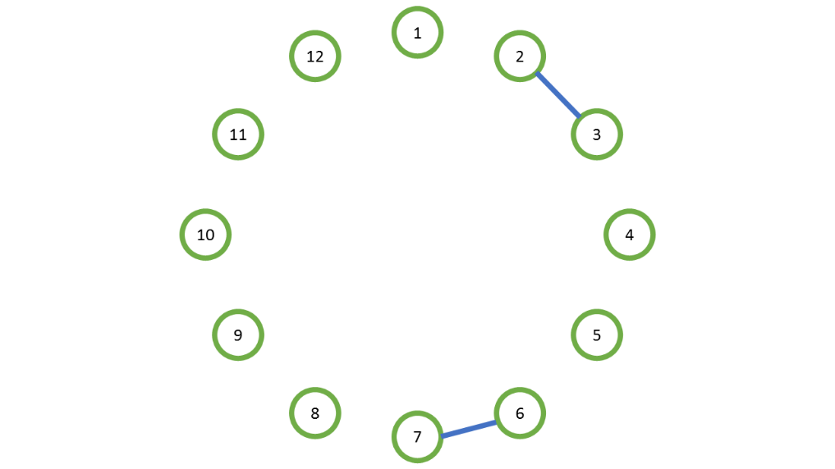

with the following WA algorithm output:

|  |  |  |  |  |  |  |  |  |  |  |  |  |
| --- | --- | --- | --- | --- | --- | --- | --- | --- | --- | --- | --- | --- |
| Lightpath | 1 | 2 | 3 | 4 | 5 | 6 | 7 | 8 | 9 | 10 | 11 | 12 |
| Wavelength | 1 | 1 | 2 | 1 | 1 | 1 | 2 | 1 | 1 | 1 | 1 | 1 |

There are 2 wavelengths in total to assign wavelengths to all the requests.